






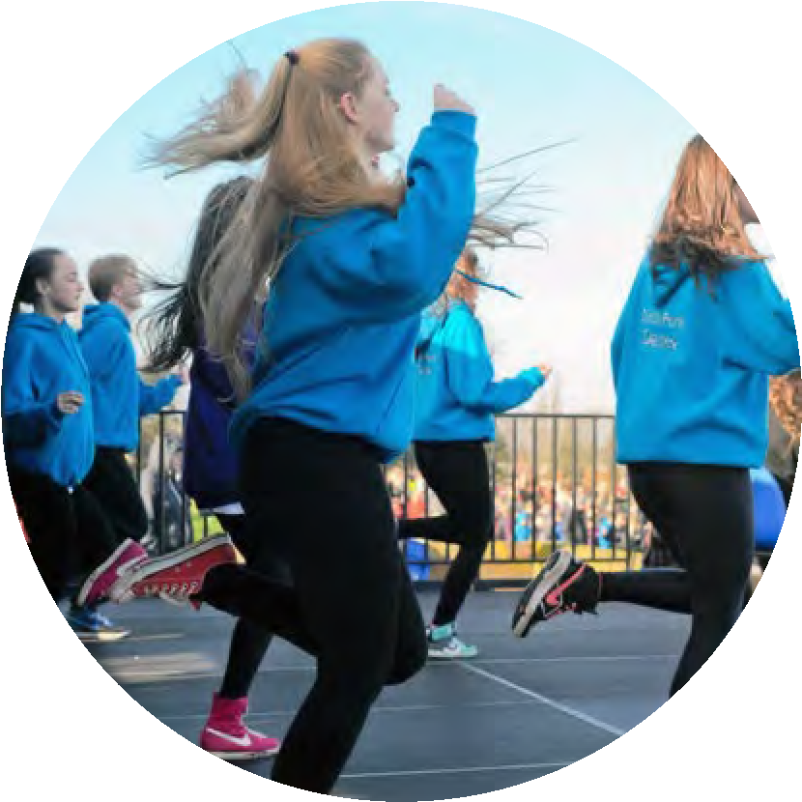
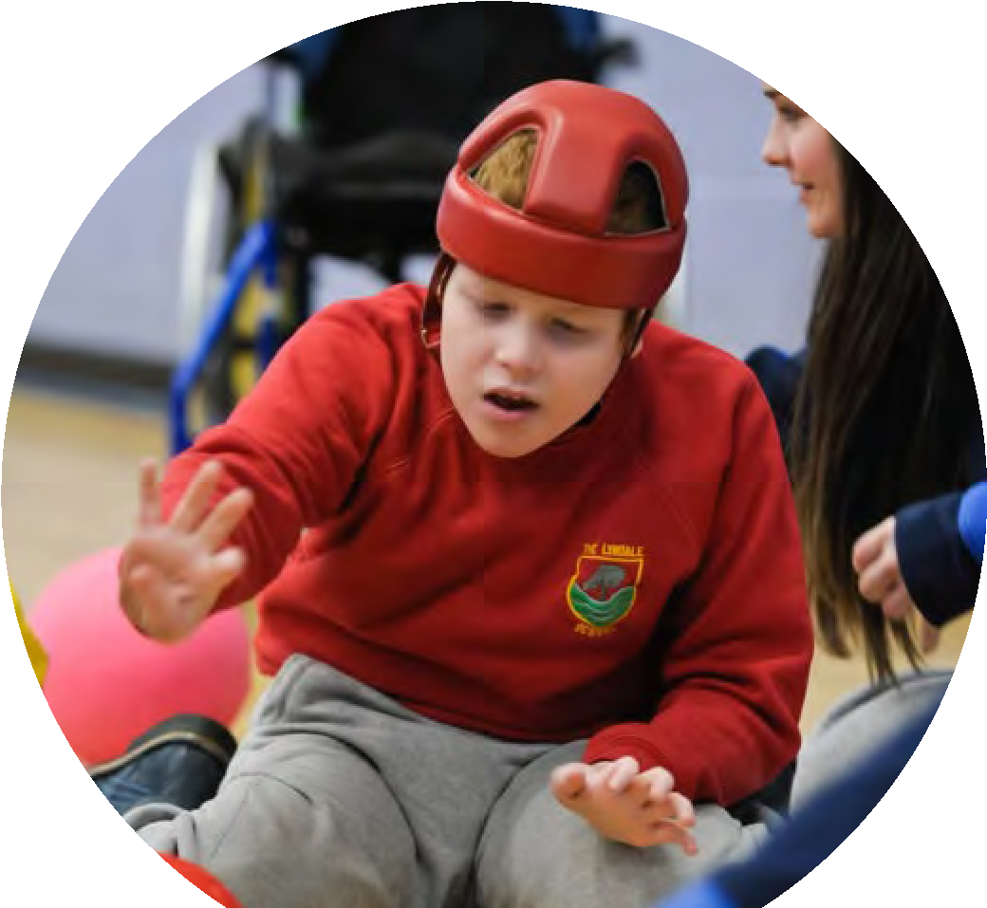
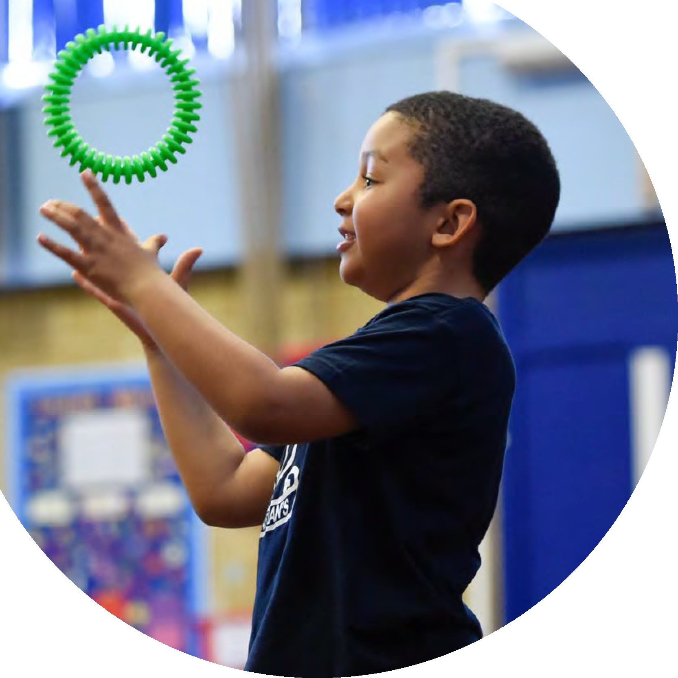


Updated September 2023
Planning, reporting and
evaluating website tool

The Primary
PE and sport
premium

Created by
Commissioned by

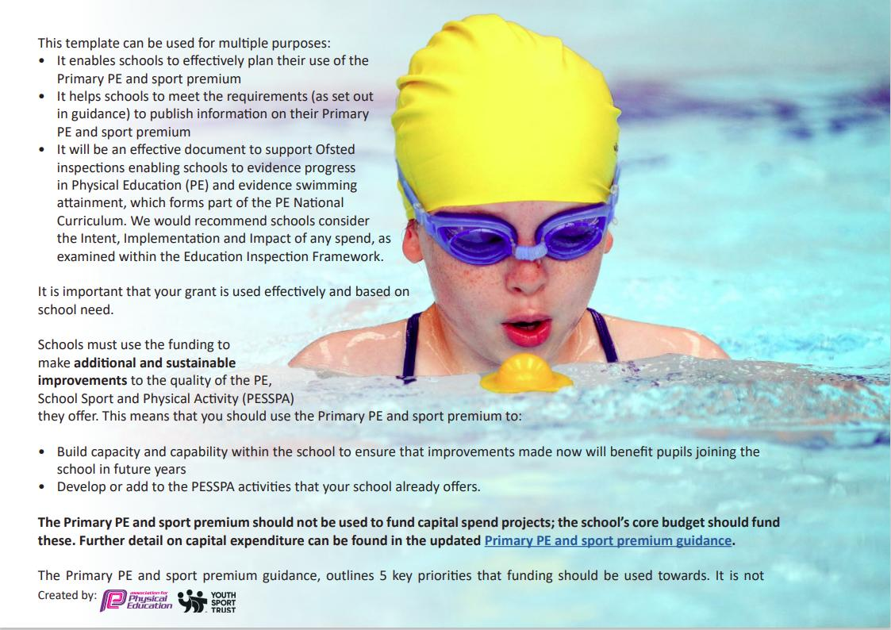
necessary that spending has to meet all the key priorities, you should select the priorities that you aim to use any funding towards.
school need. necessary that spending has to meet all the key priorities, you should select the priorities that you aim to use any funding towards.
Although completing this template is not a requirement for schools, schools are required to publish details of how they spend this funding. Schools must also outline what the impact this funding has had on pupils’ PE and sport participation and attainment and how any spending will be sustainable in the future. All funding must be spent by 31st July 2024.
The Department for Education has worked closely with the Association for Physical Education (afPE) and the Youth Sport Trust (YST) to develop this template and encourages schools to use it. This template is an effective way of meeting the reporting requirements of the Primary PE and sport premium.

Review of last year’s spend and key achievements (2022/2023)
We recommend you start by reflecting on the impact of current provision and reviewing your previous spend.
Activity/Action  - To increase the amount of daily  physical activity during lunch  play times for all children  (minimum 30 mins) led by a  specialist PE coach  2. Engagement of all pupils in regular physical activity to increase the participation of all  pupils in school games, events,  competitions, sport leadership,  extra-curricular clubs and  enrichment in addition to  curriculum delivered sessions.  3. Top up swimming lessons for pupils who have not met, who are likely to not meet the NC requirements or who are vulnerable.  4. Increase opportunities for physical  activities through Outdoor Learning  for all children Reception to Year 6  5. Pupils to attend a range of  competitive events and learn about the  importance of good sportsmanship,  humility of winning and perseverance in  adversity | Impact  Lunchtime sport coach increased children’s enjoyment and amount of daily physical activities with a range of sports offered.  90% of our previous year 6 cohort can swim competently, confidently and proficiently of a distance of at least 2 meters.  The impact of this was 100% of our previous year 6 cohort can perform safe self-rescue in different water-based situations.  Introduced new physical activities  within the curriculum (in addition  to PE) for all pupils. These  included:  • Orienteering  • Ropes  • Challenge courses  • Forest Schools  • Bushcraft  • Green Crafts  Participation in Hockey, netball, rugby  and football league games through  Dorking Sports Partnership  Won Pixham athletics tournament. | Comments  Children more engaged in outdoor  sporting activities.  Action: sports coaches to work with lunchtime supervisors to increase CPD for offering outside physical opportunities.  We will continue to provide top up swimming lessons for those that need it.  All children received outdoor learning with a range of new skills and opportunities which increased physical activity  Children loved joining in a range of competitions.

Key priorities and Planning
This planning template will allow schools to accurately plan their spending.
Action – what are you planning to do  To increase the engagement of pupils in regular physical activities- through active lunchtimes and active breaks  - Daily mile  - Ensure the long term plan is being followed through pupil monitoring and lesson observation  - Imoves Active Blasts  All staff following progressive PE curriculum planning and gaining confidence in teaching PE.  CPD for all class teachers.  All staff understanding the importance of PE and helping to implement physical activities and sports in many ways.  Be an Active Member of Dorking Schools Partnership PE | Who does this action impact?  Lunchtime supervisors/ teaching staff, coaches - as they need to lead the activity pupils – as they will take part.  Teachers - Primary teachers more confident to deliver effective PE and supporting pupils to undertake extra activities.  In future all staff to be confident and teaching at least 1 PE lesson per week.  CPD DSSP.  PE Subject Lead - consultant work to develop PE curriculum and improve outcomes and deliver CPD  Staff - develop quality of delivery through CPD  Pupils - attend regular tournaments with Dorking schools | Key indicator to meet  Key indicator 1: The engagement of all pupils in regular physical activity – Chief Medical Officers guidelines recommend that  primary school pupils undertake at least 30 minutes of physical activity a day in school  Key Indicator 1: Increased confidence, knowledge, and skills of all staff in teaching PE and sport.  Key indicator 5: Increased participation in competitive sport.  The profile of PE and spot is raised across the school as a tool for the whole-school improvement.  Key indicator 1: increasing all staff’s confidence, knowledge and skills in teaching PE and sport  Key indicator 3: raising the profile of PE and sport across the school, to support whole school improvement  Key indicator 5: increase participation in competitive sport | Impacts and how  sustainability will be achieved?  More pupils meeting their 30 mins a day of activity.  Sustainability  Resources in place and challenges rotated throughout the year.  To achieve all class teachers being confident in teaching PE.  To ensure all staff are trained and confident to increase pupil activity throughout the day.  Sustainability  PE lead and training for other staff through observation of lessons improves delivery  More opportunities for competitive sport.  Increase staff confidence in delivery of PE  Improve PE outcomes across the school. | Cost linked to the action  £4000  £5000  Coaching CPD  Supply teachers for teacher CPD time.  £2160 tbc
Purchasing of new sports equipment  - Purchase outdoor climbing equipment for EYFS to improve outdoor gross motor skills  - Purchase equipment to support  competition in KS1 and KS2 e.g. sports day  - Purchase lunchtime equipment for  each class sports leaders to run daily physical activities (e.g Physifun) | EYFS teaching team – will develop and improve gross motor skills and improve and increase physical movement.  Lunchtime supervisors – improve active lunchtimes for children | Key indicator 2 -The engagement of all pupils in regular physical activity – the Chief Medical Officer guidelines recommend that all children and young people aged 5 to 18 engage in at least 60 minutes of physical activity per day, of which 30 minutes should be in school.  Key indicator 3: raising the profile of PE and sport across the school, to support whole school improvement  Key indicator 5: increase participation in competitive sport | Children in Early years will develop and improve gross motor skills and improve and increase physical movement.  Further training continue CPD for lunchtime supervisors from Active Surrey and  Lunchtime equipment purchased will improved competition and active lunchtimes for children

Embed local club links  Tennis, cricket, golf, football, rugby and girls football clubs to run sessions for our children  Improve quality of dance at Surrey Hills | Teachers new to Surrey Hill’s, ECTs  Staff - develop quality of delivery through CPD  Pupils - improve outcomes when attending local tournaments  Teachers new to Surrey Hills | Key indicator 2 -The engagement of all pupils in regular physical activity – the Chief Medical Officer guidelines recommend that all children and young people aged 5 to 18 engage in at least 60 minutes of physical activity per day, of which 30 minutes should be in school.  Key indicator 3: raising the profile of PE and sport across the school, to support whole school improvement  Key indicator 4: Broader experience of a range of sports and activities offered to all pupils.  Key indicator 1: increasing all staff’s confidence, knowledge and skills in teaching PE and sport  Key indicator 2 -The engagement of all pupils in regular physical activity – the Chief Medical Officer guidelines recommend that all children and young people aged 5 to 18 engage in at least 60 minutes of physical activity per day, of which 30 minutes should be in school.  Key indicator 3: raising the profile of PE and sport across the school, to support whole school improvement  Key indicator 4: Broader experience of a range of sports and activities offered to all pupils. | Sustainability  Team teaching from PE lead and training for other staff through observation of lessons improves delivery  Improved level of training ensures delivery of high quality lessons.  Primary teachers more confident in teaching dance.  More children engaged in after school and lunchtime activities involving dance  Increase range of dance offered to all pupils. | Cost of dance teacher  Cost of imoves

Key achievements 2023-2024
This template will be completed at the end of the academic year and will showcase the key achievements schools have made with their Primary PE and sport premium spending.
Activity/Action | Impact | Comments

Swimming Data
Meeting National Curriculum requirements for swimming and water safety.
Priority should always be given to ensuring that pupils can perform safe self-rescue even if they do not fully meet the first two requirements of the National Curriculum programme of study
Question | Stats: | Further context  Relative to local challenges
What percentage of your current Year 6 cohort can swim competently, confidently and proficiently over a distance of at least 25 metres? | % | Use this text box to give further context behind the percentage.  e.g., 30% - we are struggling to get pool space due to our local pool closing so we have had to use a much smaller local school pool. We have had to limit the number of pupils attending swimming lessons during one term which means some pupils have attended fewer swimming lessons than others.
What percentage of your current Year 6 cohort can use a range of strokes effectively [for example, front crawl, backstroke, and breaststroke]? | % | Use this text box to give further context behind the percentage.  e.g., Even though your pupils may swim in another year please report on their attainment on leaving primary school at the end of the summer term 2024

What percentage of your current Year 6 cohort are able to perform safe self-rescue in different water-based situations? | % | Use this text box to give further context behind the percentage.
If your schools swimming data is below national expectation, you can choose to use the Primary PE and sport premium to provide additional top-up sessions for those pupils that did not meet National Curriculum requirements after the completion of core lessons. Have you done this? | Yes/No
Have you provided CPD to improve the knowledge and confidence of staff to be able to teach swimming and water safety? | Yes/No
Signed off by:
Head Teacher: | Jacky Fyson
Subject Leader or the individual responsible for the Primary PE and sport premium: | Immie Walker
Governor:
Date: | 22.11.2023

